Project Design Phase-II

Data Flow Diagram & User Stories

|  |  |
| --- | --- |
| Date | 18 October 2022 |
| Team ID | PNT2022TMID43478 |
| Project Name | Personal Assistance for Seniors Who Are Self-Reliant |
| Maximum Marks | 4 Marks |

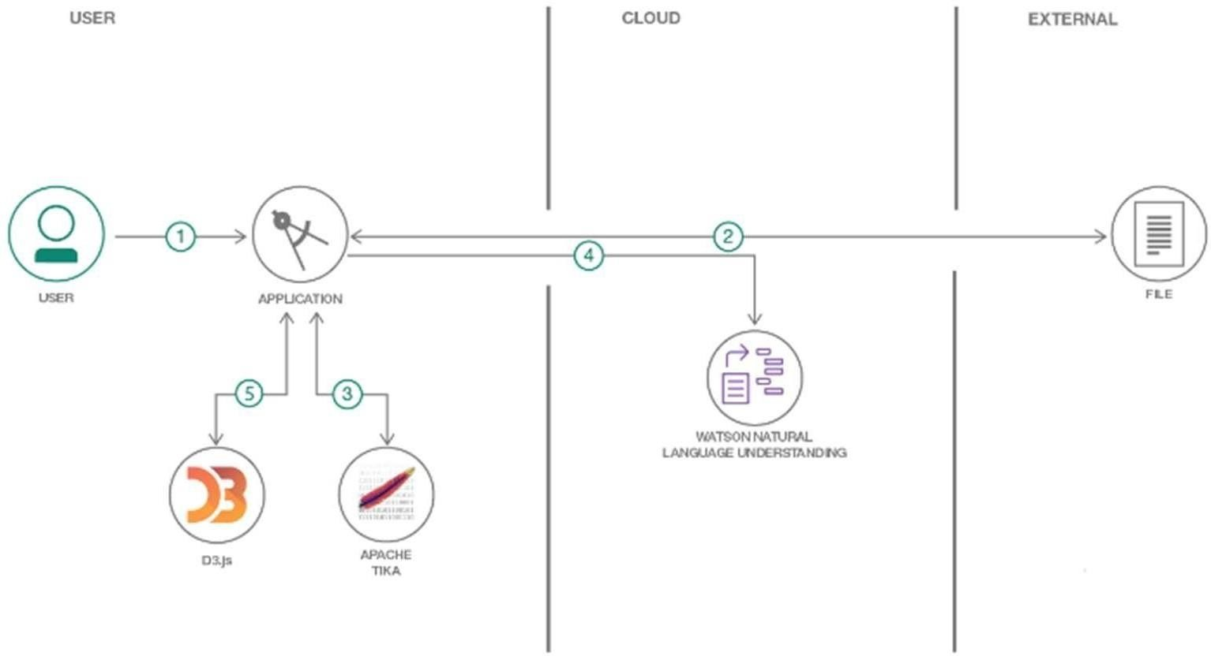

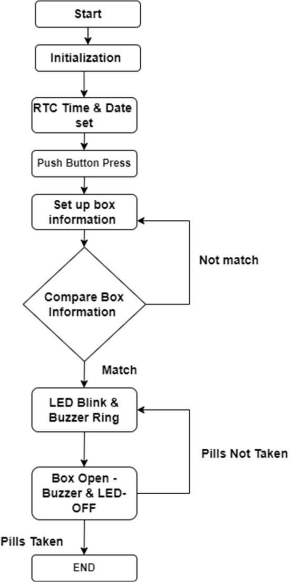

User Stories

|  |  |  |  |  |  |  |
| --- | --- | --- | --- | --- | --- | --- |
| **User Type** | **Functional Requireme nt(Epic)** | **User Story**  **Number** | **User Story / Task** | **Acceptance criteria** | **Priority** | **Release** |
| Customer (Senior  citizen) | Caretaker | USN-1 | As a user, I want to take Medicines on time and monitor my health | I want to Take Medicines On time | High | Sprint-1 |
| Customer (Alzheime r patient) | Smart medicine box | USN-2 | As a user, I want to take my tablets on time by voice command | I want to take my tablets on time by voice  command | High | Sprint-1 |
| Custome r  (Mentally idled patient) | Caretaker | USN-3 | As a user, my patient needs to take medicines on time and monitoring the activity | My patient needs to take medicines on time | Medium | Sprint-2 |
| Custome r (Coma patient) | Caretaker | USN-4 | As a user, my patient medication  time and prescription should load in database for upcoming week | My patient medication time and prescription should be in database list | Low | Sprint-4 |
| Custome r  (Disable d people’s) | Smart medicine box | USN-5 | As a user, I need to take my medicine in nearby places with light notification | I need to take my medicine in nearby places with  light  notification | Medium | Sprint-3 |